Helping Parish and Town Councils Vote for 20mph
20’s Plenty for Us is supporting local councils that want 20mph in their community where people live, work and play. As the Highway Authority, Suffolk County Council sets local speed limits and erects signs and road features, such as 20mph roundels. Demonstrating widespread local community support for 20mph helps to persuade Suffolk County Council to implement it more widely and cost-effectively. Counties in England such as Cornwall, Oxfordshire and Lancashire have agreed 20mph for every settlement, as have counties throughout Wales, with 20mph promised by the Scottish Government. In all of those places, 30mph is becoming the exception and will only be on roads that are demonstrably safe for all road users, particularly pedestrians, children and the elderly.
28 million people already live where 20mph is, or soon will be, the norm.
Adopting a motion in favour of 20mph will help to:
- Achieve a 20mph speed limit on roads in your community where people and motor
vehicles mix.
- Demonstrate to your Highway Authority the desire for 20mph county-wide, making it
both cheaper and easier to implement.
Motion
[Your Parish or Town council name]:
Supports the 20’s Plenty for Suffolk campaign;
Calls on Suffolk County Council to implement 20mph in [your place]; and
Will write to Suffolk County Council to request 20mph speed limits on streets throughout Suffolk where people live, work, shop, play or learn, with 30mph as the exception on those roads, where full consideration of the needs of vulnerable road users allows a higher limit.

Why 20mph?
- Safer: The UK’s Department for Transport estimates that a 1mph lower speed in built-up areas reduces road casualties by 6%. Successful 20mph schemes result in 30% fewer casualties.
- Cleaner (and quieter): 20mph reduces tail-pipe emissions by 25% compared with 30mph and is 50% quieter.
- Healthier: 20mph helps to remove the blight of vehicle speed and builds inclusive communities where human activity, including walking, cycling and social interaction, takes
first place.
- Popular: National and local surveys consistently find 70% support in residential streets;
such support rises after 20mph limits are introduced.
- Accepted as normal by UK local authorities where 28m people live, including all of Wales - where 20mph will soon be the default speed on restricted roads - and soon throughout Scotland. 20mph is global best practice where people mix with motor traffic.
- Compliance: 20mph is as enforceable as any speed limit. Even with no additional police enforcement, speeds reduce by up to 6mph on faster roads.
- Affordable (and cost effective): Multiple economic, societal and environmental benefits at
low cost. Entry signs plus repeaters remind drivers with no need for physical calming or additional enforcement.
- Little journey time impact: Congestion, junctions and crossings are the determining factors
in built up areas and 20mph rarely affects journey times or bus timetables.
Wide area 20mph as a norm increases engagement and benefits whole communities. Allowing exceptions where faster speeds are safe for all road users avoids the need to prove lack of safety in order to adopt 20mph.
While introducing 20mph outside a school may seem logical, there is no evidence that this is where the danger lies. Families need a safe route for the whole journey, not just the last 100 metres outside the school.
Signed schemes with public engagement are successful and cost-effective!

More on wide area 20mph benefits
Signed only limits do reduce road speeds
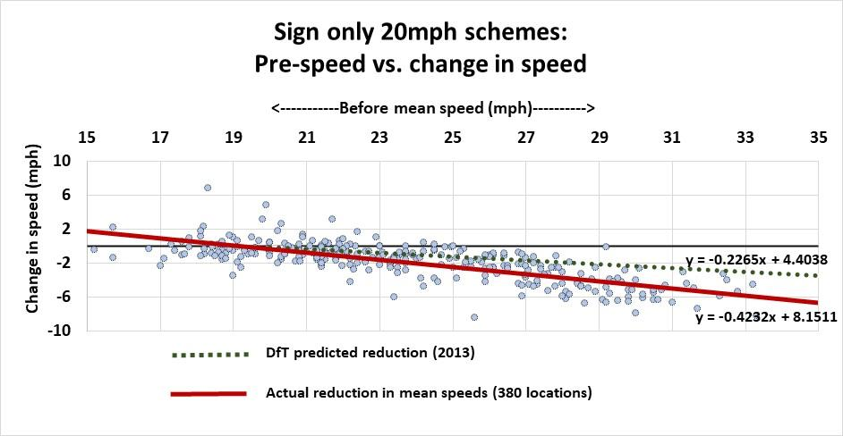
Road safety improves even without 100% compliance with a 20mph limit. Even a small change in the average speed results in significant casualty savings (6% reduction in casualties per 1mph reduction in speed). However, recent data shows that reductions of 3–6mph in mean speeds are achievable without physical traffic calming or enforcement. The chart below shows the relationships between pre-scheme speeds and the impact of lowering the speed limit in nearly 400 locations, demonstrating that reductions are greatest on faster roads.
Over time, as 20mph limits become more established and in-car speed limiters become more widespread, compliance levels will increase and average speeds will reduce further.

Cost effective for drivers …
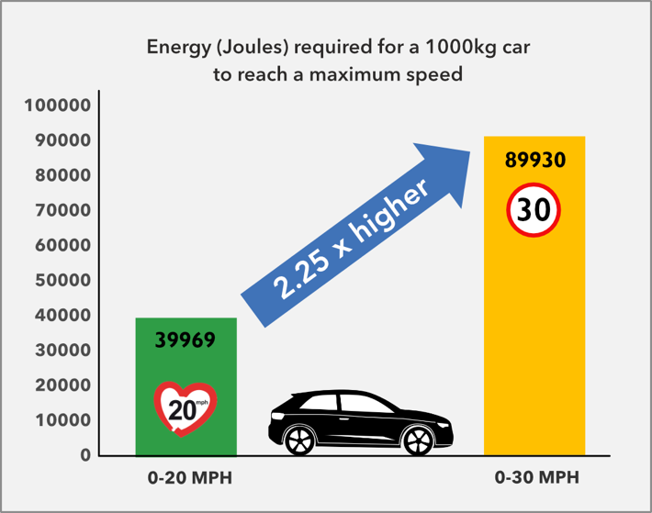
Reducing peak road speeds around people saves both energy and cash. Research from Future Transport shows fuel efficiency peaks with speed capped at 20mph. This “real life” model factors in stop/start urban traffic. Less acceleration saves precious resources, since getting to 30mph requires over twice as much energy as getting to 20mph. Drivers can save up to 10p per mile without trips taking longer. That's a 30% saving in urban fuel costs.

… and for local authorities
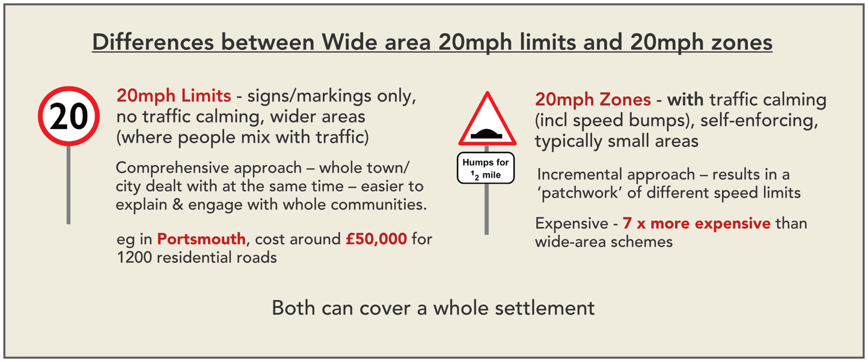
The earliest 20mph zones required extensive road engineering, such as humps and bumps to achieve full compliance with 20mph. With research showing significant reductions in speeds without engineering – up to 6mph on faster roads – enlightened councils are now implementing schemes at much lower cost – typically £5 to £10 per person. Using signs and lines, education and, sometimes, light touch engineering is 7x more cost effective than speed bumps.
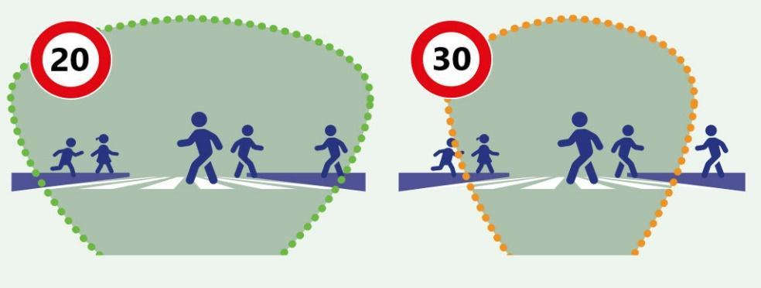
More time to see …
Children under 14 are unable to judge traffic speeds greater than 20mph reliably, putting them at greater risk when crossing the road.
A driver’s range of vision is greater at 20mph giving more time to spot potential danger and react in time to avoid a collision.
… and more time to stop
Travelling more slowly reduces stopping time. At the point at which a car travelling at 20mph has stopped, the 30mph car is still doing 24mph.
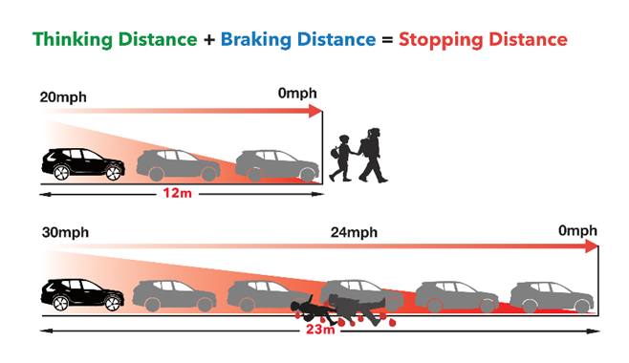

Safer streets for all, particularly children and the elderly
As well as lowering the actual risk of serious and fatal injury by a factor of seven compared with 30mph, 20mph also reduces fear and intimidation from motor vehicles, especially for vulnerable road users.
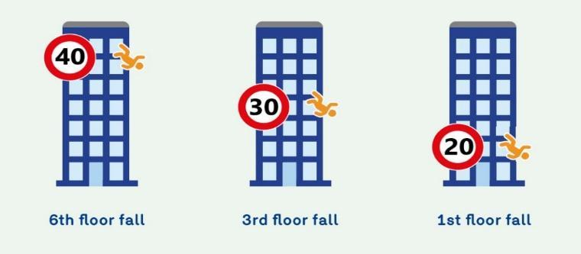
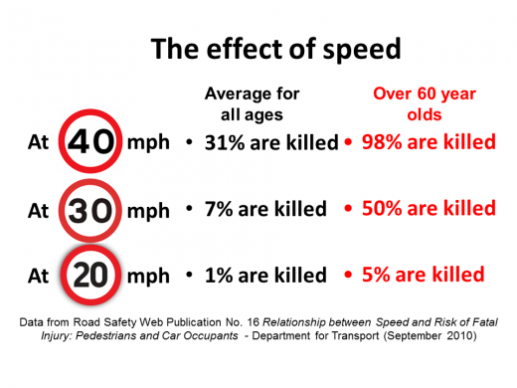
Better physical and mental health
Inactivity and pollution are major causes of early death in the UK. 20mph is associated with greater activity and lower air and noise pollution: tailpipe emissions are a 1/3 higher at 30mph than 20mph and that 30mph is twice as noisy, leading to reduced health risks, improved sleep patterns and lower levels of anxiety. 20mph also helps sociability and reduces loneliness.
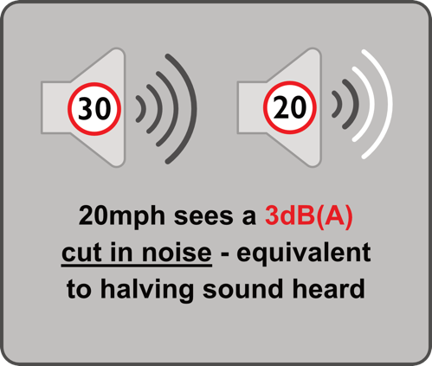
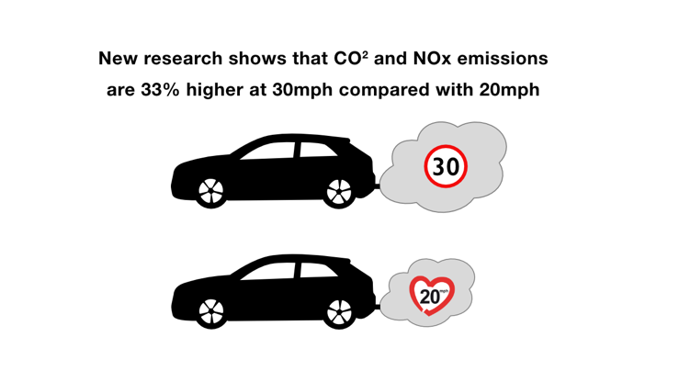

Greater activity
20mph helps to enable more walking and cycling, which leads to reduced obesity, heart disease and loneliness. Retaining mobility enables the elderly to live independently for longer, which reduces social care costs. Children can play out and learn independent mobility, with less taxi duty for parents and carers. 20mph enables lifestyle changes, renewed community life and a positive atmosphere. Our towns and villages will be more attractive, liveable and sustainable places.
Enforcement and compliance
20mph is as enforceable as any speed limit. While some police forces, such as Avon & Somerset and the Metropolitan Police prioritise speeding enforcement, even without regular enforcement, 20mph limits reduce speeds, collisions and casualties - see case studies below. Driver education through community engagement and compliance increases over time, as drivers become used to 20mph.
In-car technology will further increase compliance: many drivers welcome Intelligent Speed Assistance to ensure that they do not break the law inadvertently. Compliant drivers effectively become pacer vehicles for following traffic. Black boxes in vehicles will help further by enabling the automatic recording of collision speeds and potentially determining liability for collisions.
Better for business
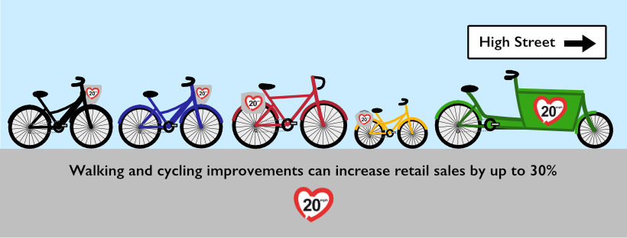
There is evidence of retail sales increasing by up to 30% when people walk or cycle rather use their car to visit their local high street. People also visit their local high street more often when they walk or cycle, on average, spending 40% more than those who drive (source: TfL 2013). The association of 20mph with increased walking and cycling shows the benefit to local businesses.
Lowering road casualty costs
Road casualties are predictable and preventable and cost the UK over 2% of GDP. With speed reported as a factor in nearly half of fatalities, and likely causative in many more, implementing 20mph reduces casualty costs, as well as pain and suffering.
Wide area 20mph limit schemes cost no more than £5-10 per head and typically pay back within months. Larger areas tend to be cheaper per person, since they need fewer signs. Smaller places can band together to share one-off costs, such as the Traffic Regulation Orders.
A calculator on the 20’s Plenty website shows the cost/benefit for your Highway Authority.
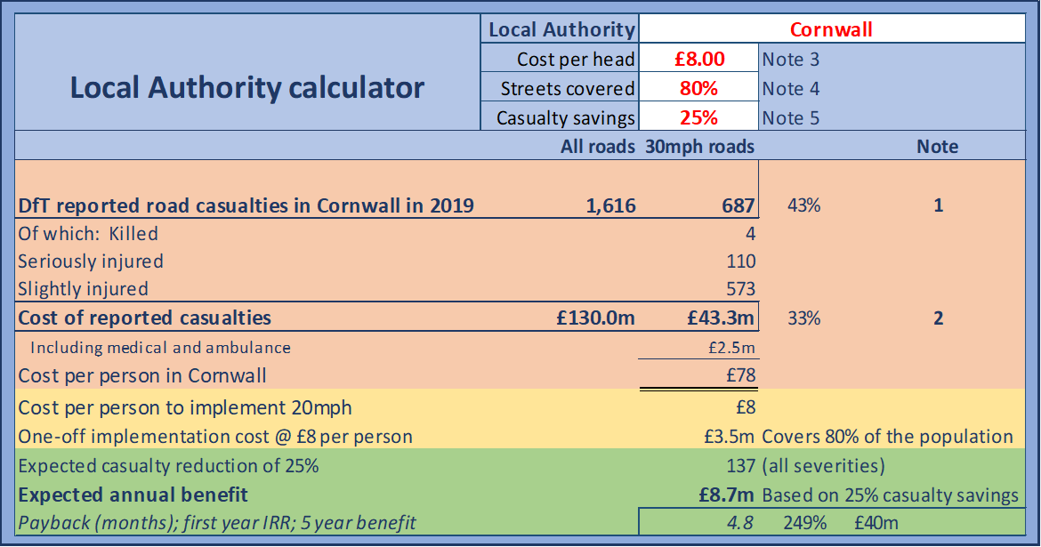

CASE STUDY 1: Scottish Borders, Oxfordshire, Wales, Kent and Hampshire
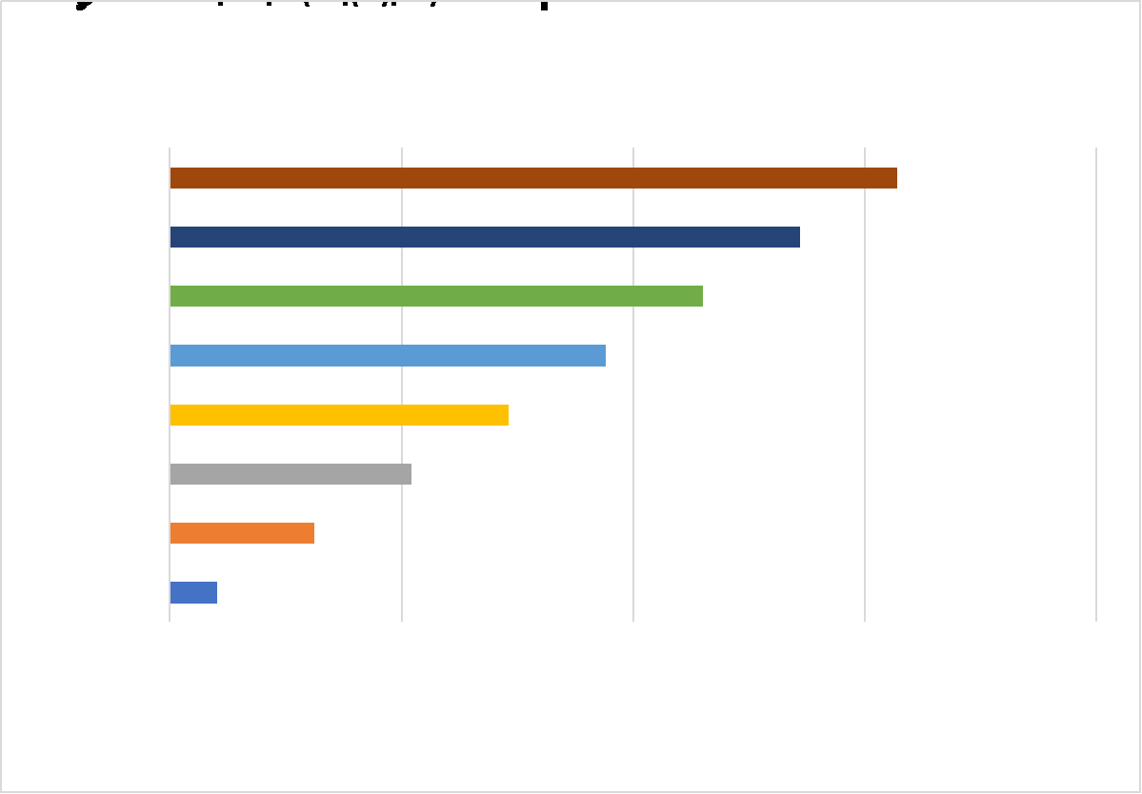
In a scheme involving over 100 communities in the Scottish Borders, speeds reduced by an average of 3mph, even without additional enforcement. Greater reductions - up to 6mph - were seen in places where higher mean speeds were recorded before 20mph was implemented. This pattern was repeated in schemes in the Wales, Oxfordshire, Kent, Hampshire, Edinburgh and most recently on TfL red routes.

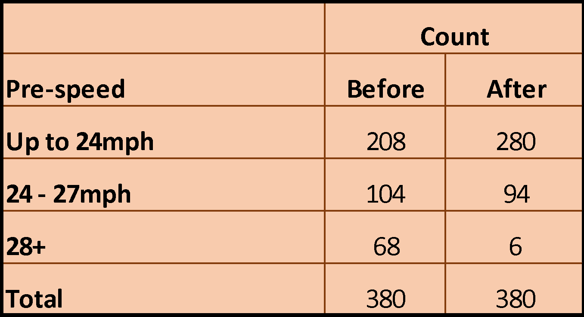
Another significant finding was the total number of places recording higher speeds fell. Out of nearly 400 sites, 68 had mean speeds above 28mph before 20mph was implemented. This reduced by 90% to just six after implementation.
The chart below shows 1) an increase in the number of low speed roads and 2) a higher concentration of speeds around the 24mph enforcement threshold.

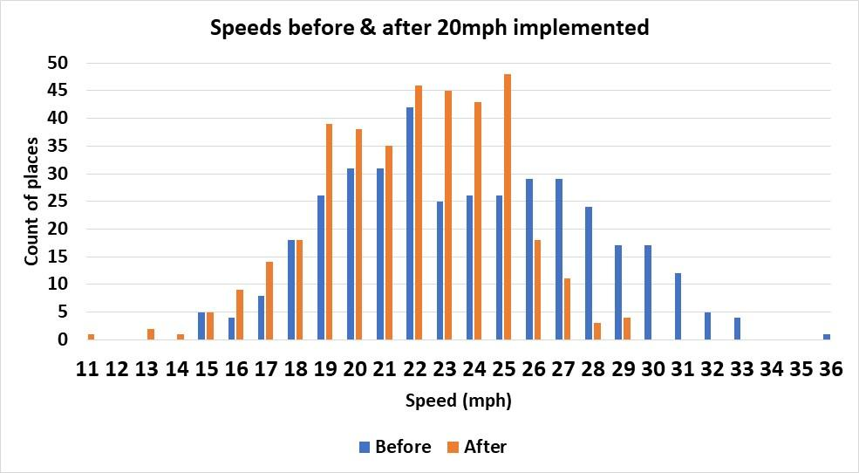
CASE STUDY 2: Edinburgh vs Belfast
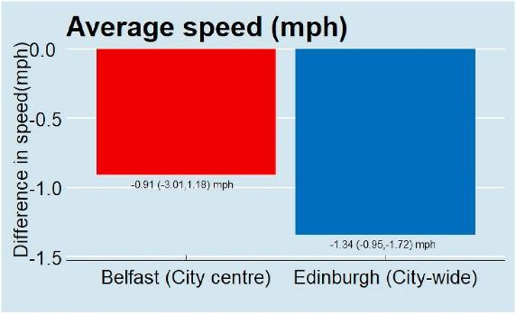
Two contrasting schemes show the massive benefit of reduced casualties and speeds that come from implementing 20mph over a wide area of Edinburgh versus a small-scale, limited scheme in Belfast.
- The Belfast implementation on just 76 city-centre streets had speeds that were already below 20mph and included 27 partly pedestrianised streets. In addition, there was little community engagement or marketing of the scheme. Predictably, speeds and casualties changed little.
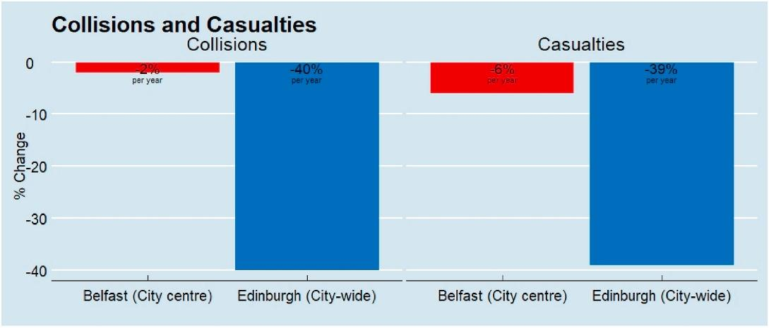
- In Edinburgh, by contrast, the widely publicised scheme covering the whole of the city resulted in lower speeds and casualties reduced by 39%, with fatalities down by a quarter.

The difference in outcomes is stark: a small and isolated 20mph scheme without publicity saw little change on congested city-centre streets where speeds were already low. A city-wide scheme with engagement and education and including the city-centre, suburbs, residential areas, shopping streets gained significant speed and casualty reductions.
CASE STUDY 3: Bristol
Much of Bristol is now 20 mph. Studies found that speeds on 94% of surveyed roads had fallen, with an overall 2.7mph reduction in average speeds offering estimated casualty reductions per year of 4.53 fatalities, 11.3 serious injuries and 159.3 slight injuries.
These total an estimated cost saving of over £15 million per year - annual savings over 5 times greater than the one-off roll-out cost of £2.77m mostly funded by Government. Over a ten-year period, 20mph in Bristol will have saved 45 lives, 113 serious injuries, 1,593 minor injuries, and accrued savings of over £147m net - a fantastic return on a public health investment! 20mph also saves drivers on average £50 per vehicle per year on fuel.
CASE STUDY 4: Faversham
In this historic market town of 20,000 people in Kent, 20’s Plenty for Faversham successfully campaigned for a town-wide 20mph limit, which went live in September 2020. As well as being popular, speeds reduced by 4–5 mph on the faster roads.
The strength of local support and the technical design persuaded Kent County Council that it would be more cost-effective to implement a town-wide 20mph speed limit. The highway authority accepted low-cost techniques to reduce traffic speeds: attractive gateways to the settlement announcing the speed limit change and resident-led ‘Community Corners’, as planters at key locations.
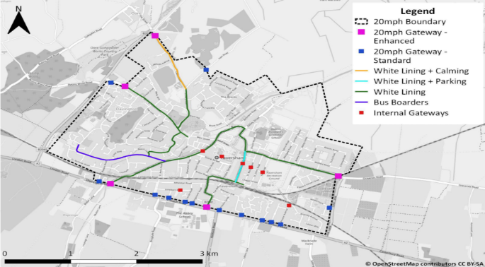

Default speed limits are set by national governments. Local Highway Authorities can choose 20mph as the norm for residential streets and town and village centres and make 30mph the exception where demonstrably safe.
https://www.20splenty.org/scotgov_says_20splenty
https://www.gov.uk/government/publications/setting-local-speed-limits/setting-local-speed-limits
https://www.20splenty.org/20mph_fuel_savings
https://www.20splenty.org/20mph_casualty_reduction
https://www.20splenty.org/20mph_vfm
https://www.20splenty.org/noise_and_speed
https://www.20splenty.org/tfl_20mph_data
https://www.20splenty.org/cost_benefit_calculator
https://www.20splenty.org/tfl_20mph_data
https://www.sciencedirect.com/science/article/pii/S2214140521001717?via%3Dihub
https://www.edinburghnews.scotsman.com/news/transport/edinburgh-20mph-speed-limits-deaths-crashes-and-casualties-reduced-by-20mph-limit-researchers-say-3861288
https://uwe-repository.worktribe.com/output/875541

